Project 3: Final Cloud Backups and Archiving Deployment Runbook

Matthew Santiago
University of Maryland Global Campus
CCS 630 Cloud Infrastructure Planning, Design, and Configurations
Alan Castillo
February 23, 2025

Executive Summary
This report provides a evaluation and guide for implementing AWS cloud backup solutions for BallotOnline. After a analysis of the cloud service providers, Amazon S3 was chosen as the primary backup service because of its scalability, data availability, security, and performance. This report describes the implementation steps and monitoring tools and how they will connect with our current data center and help with seamless transition to the cloud.
Overview
The overall objective of this project was to design and implement a cloud backup deployment for BallotOnline. This deployment will serve as the primary storage for frequently accessed data. The deployment involved creating a Virtual Private Cloud (VPC) with public and private subnets, integrating NetApp BlueXP for seamless data synchronization, and monitoring usage and costs using AWS CloudWatch. The approach detailed below guarantees high availability, scalability, and cost efficiency.
Cloud Service Offering for Backups and Archiving
In assessing cloud service offerings, Amazon S3 and Amazon S3 Glacier were evaluated, and Amazon S3 was chosen as the primary backup solution and Amazon S3 Glacier was chosen for long-term storage of the backups. Amazon S3 was chosen for data backup due to its features such as “scalability, data availability, security, and performance” (Amazon Web Services, 2024). Also its ability for frequent access in order to have millisecond level retrieval time. Although, Amazon S3 Glacier was chosen for archival storage because it is cheaper, the data retrieval time takes longer, minutes to hours (Amazon Web Services, 2024). The main benefit of Amazon S3 is that it is used for daily accessed storage while Amazon S3 Glacier is appropriate for infrequent data access. The SWOT analysis of Amazon S3: the strengths of Amazon S3 is its scalability, performance, cost flexibility, and compliance (Amazon Web Services, 2024). The main weakness is that it is more expensive than Amazon S3 Glacier (Amazon Web Services, 2024). The opportunities of Amazon S3 is multi-region replication for disaster recovery (Amazon Web Services, 2024). The threats of Amazon S3 are vendor lock in and unmanaged costs. The integration with the our current data center is permitted by AWS Storage Gateway and it allows for the backup and restoration (Amazon Web Services, 2024). The costs differ by the type of storage and also include charges for data transfer and expedited retrievals from Glacier. The usage and performance of the service will be monitored using AWS CloudWatch. This service will be accessible to the users through profiles and the applications that will be running on Amazon EC2, but administrators will access the Management Console. Payment will be done through Amazon’s pay as you go model on a monthly basis.
Create a VPC with Private and Public Subnets
To start, first make sure that you are in the correct region. Go to the VPC console. Create a new VPC called ‘cca630VPC’ with a CIDR block of 10.0.0.0/26 then go to the subnets section and create 4 subnets. Each subnet should be clearly labeled, 2 as private and 2 as public. The subnets will have smaller CIDRs like 10.0.0.0/28, 10.0.0.16/28, 10.0.0.32/28 or 10.0.0.48/28. Then, go to routes sections and create 2 routing tables 1 for the public and 1 for the private subnets. During creation make sure to link the correct subnets to the routing tables. After that go to the internet gateway section and create a new internet gateway. Once created attach the gateway to the VPC. Go back to the route tables and add a route of 0.0.0.0/0 linked to the internet gateway on the public route table. Next go to the NAT Gateway section and create a new NAT gateway. Link it to the public subnet and allocate an IP address to it. Go back to the route table section and add another route of 0.0.0.0/0 to the private route table linking the NAT Gateway to the route table.
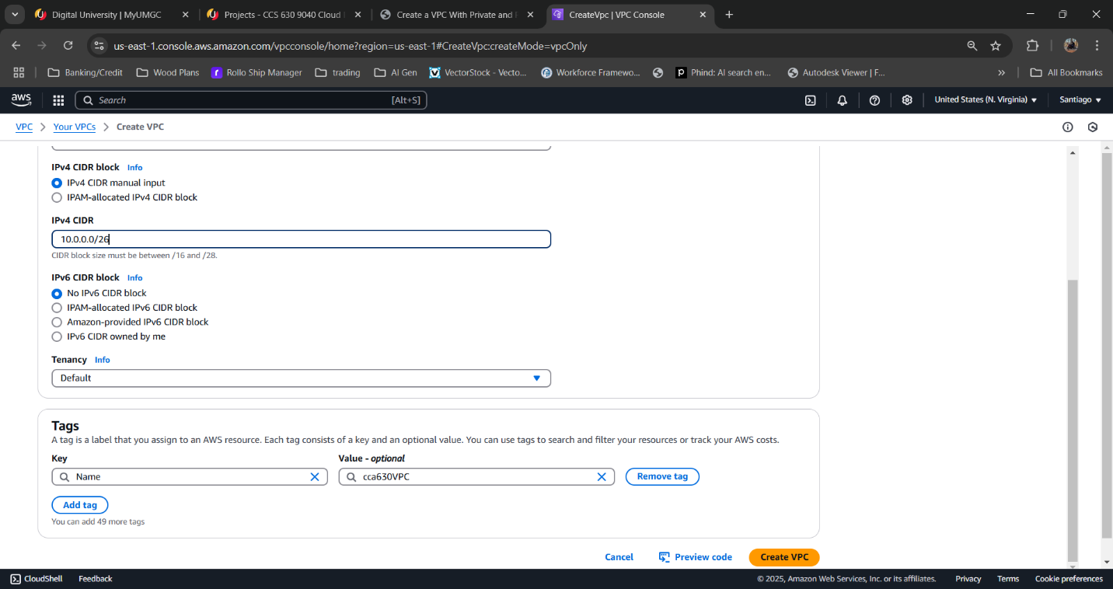
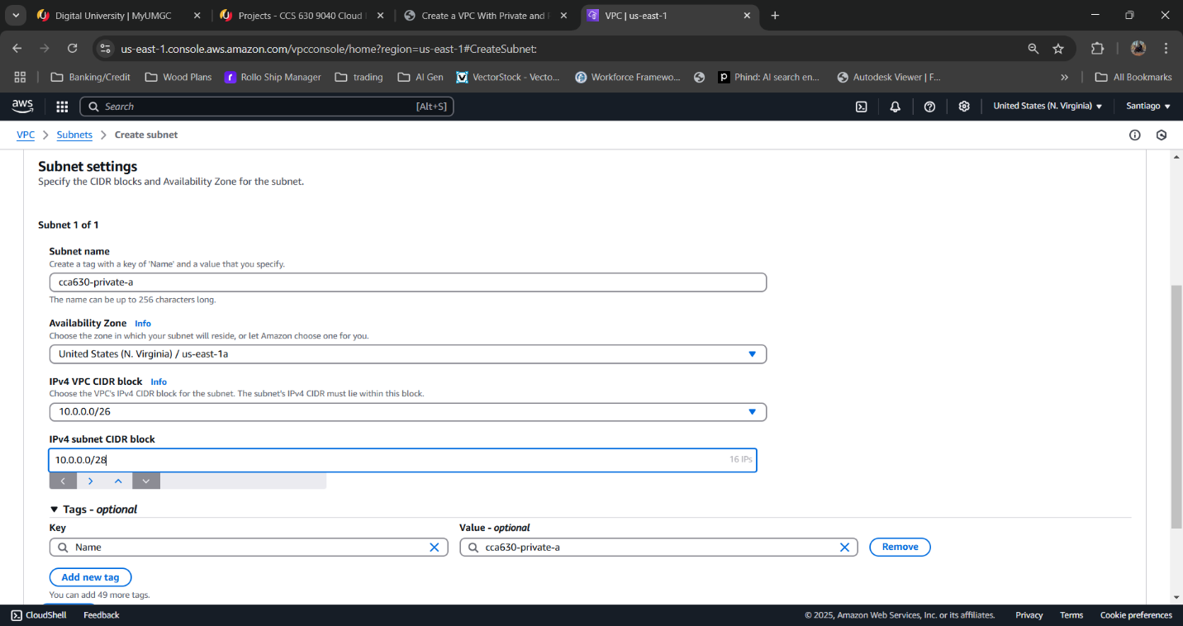
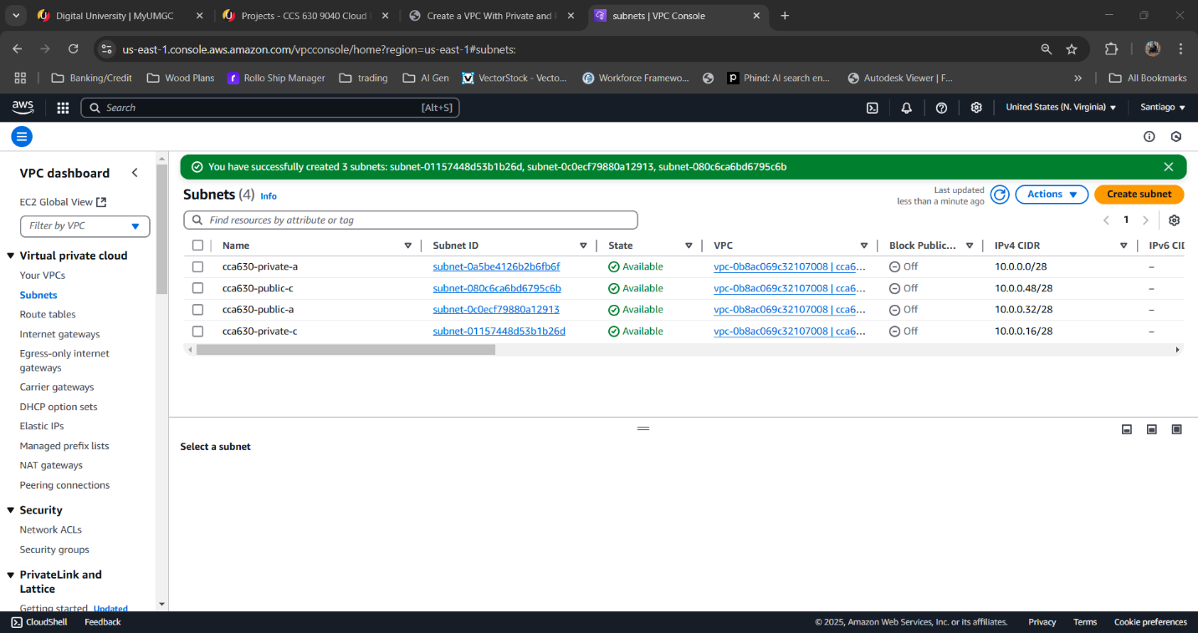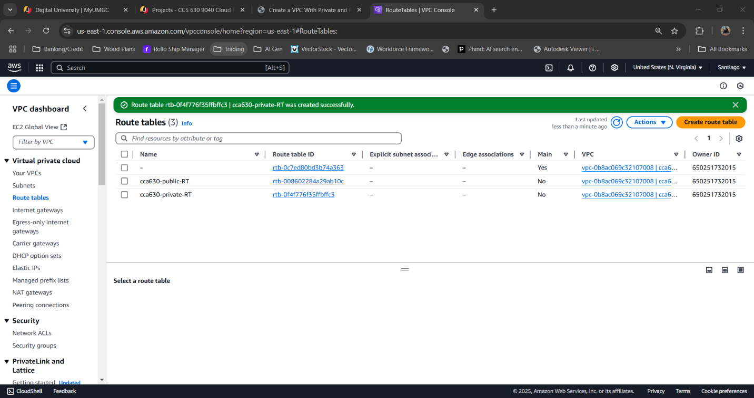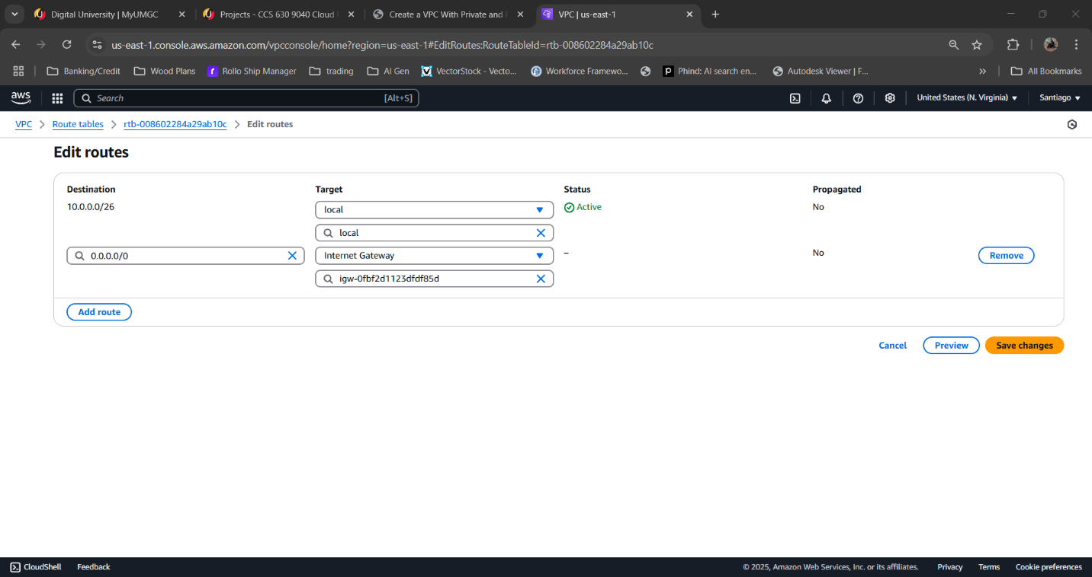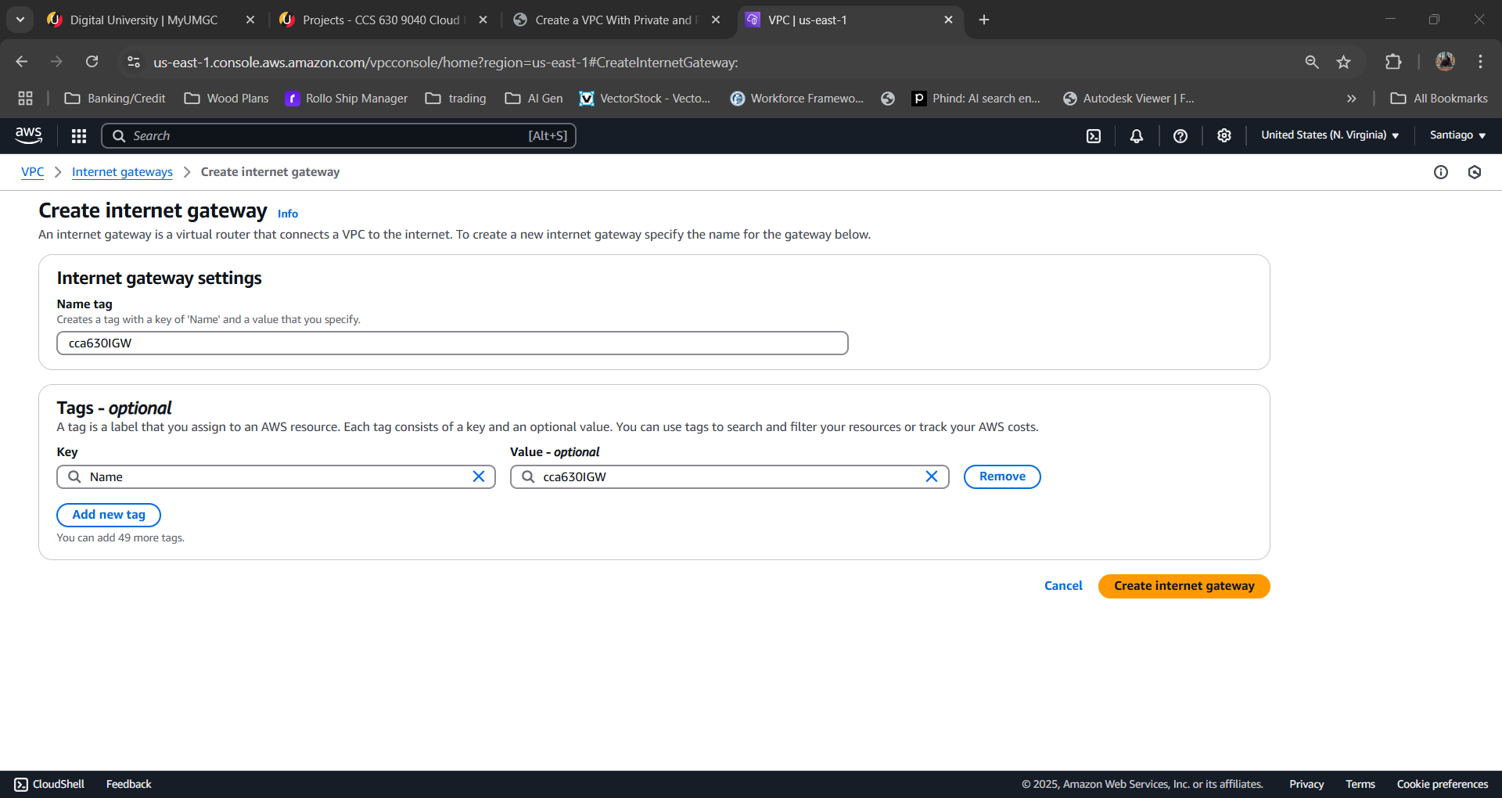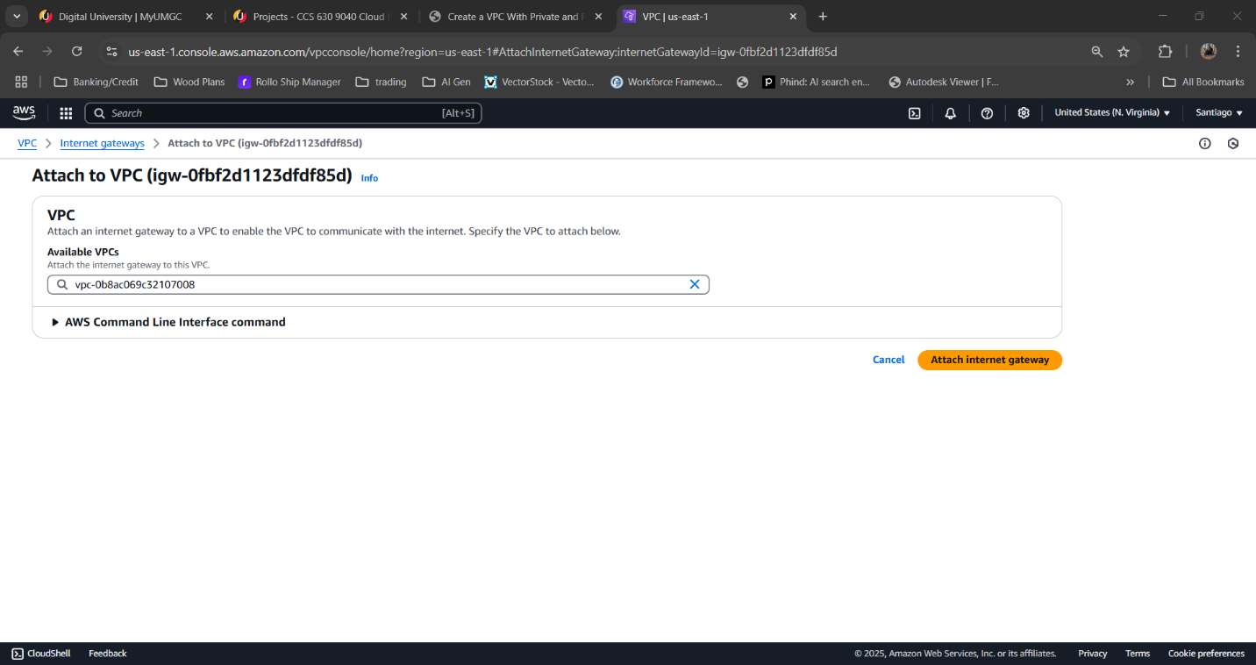

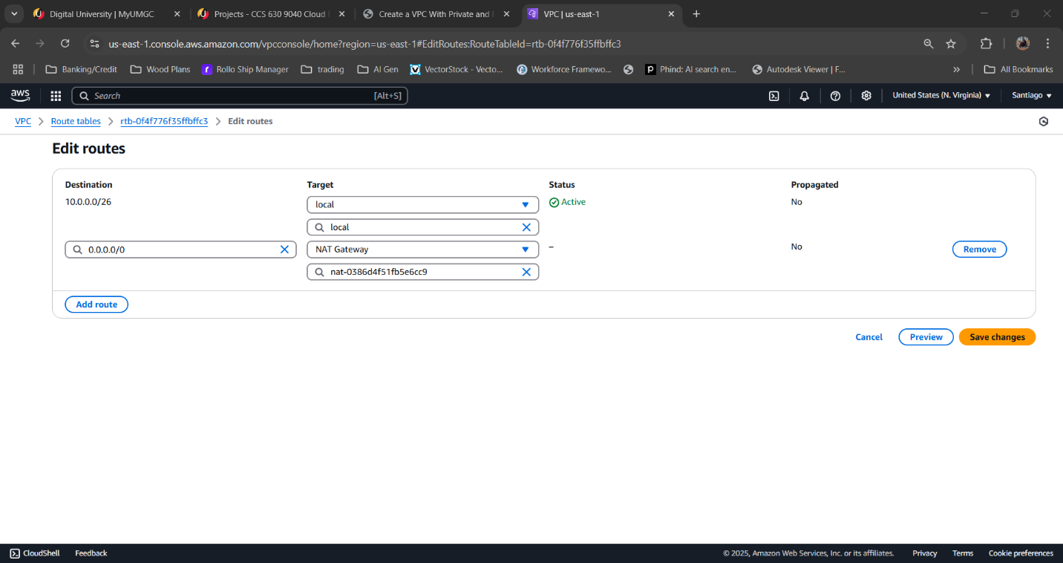
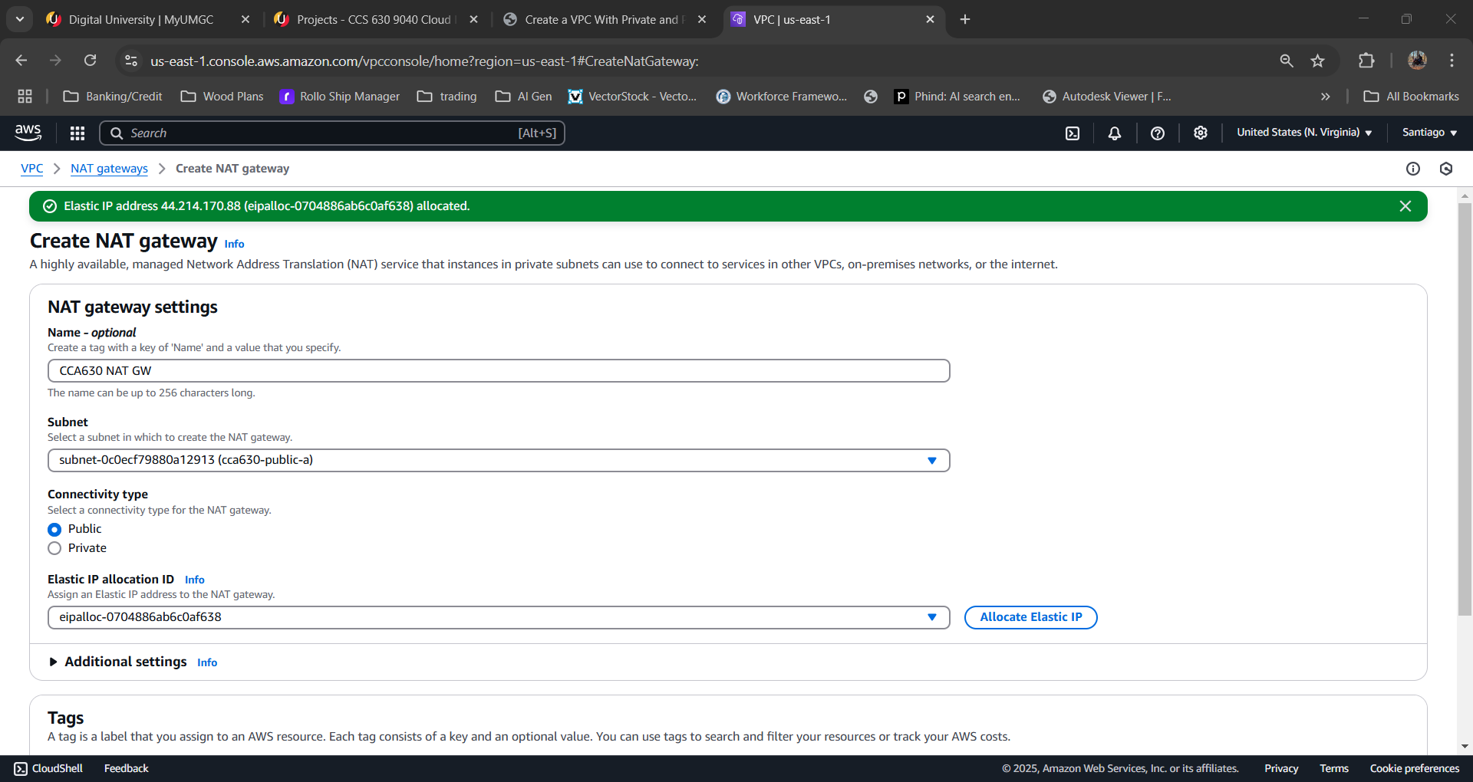


Create S3 Bucket
To store files, open the Amazon S3 console and create a new bucket in the region you choose and accept the default settings for the rest.
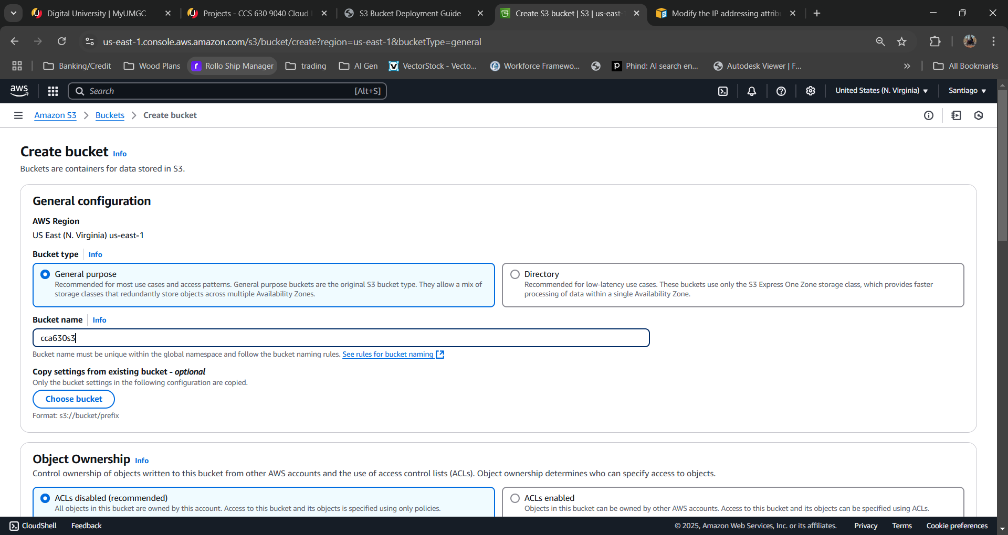

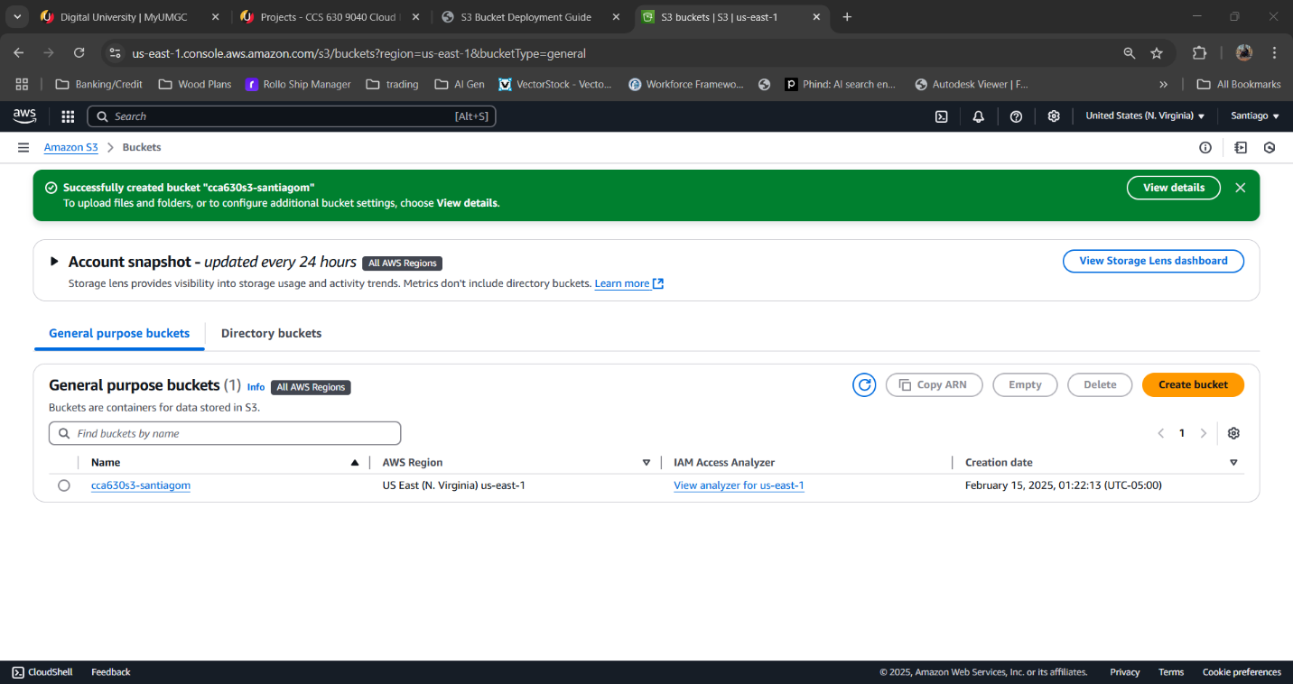
Cloud Sync Service
Next you will need to login to NetApp BlueXP which has a Cloud Sync function which will be used to sync our datacenter files into the AWS S3 bucket through a data broker. To do this you need to set up the data broker with the BallotOnline credentials and IP address to link to our data center. Then when the data broker askes for AWS credentials click the cloudformation link for instructions on linking through cloud formation automatically. Copy the url the data broker provides. Go to AWS cloud formation and create a new deployment through template and past the url then click create and wait for the process and finish. Once CloudFormation is done, the sync connection will show on NetApp and start moving the files from our datacenter to the Amazon S3 bucket we created.
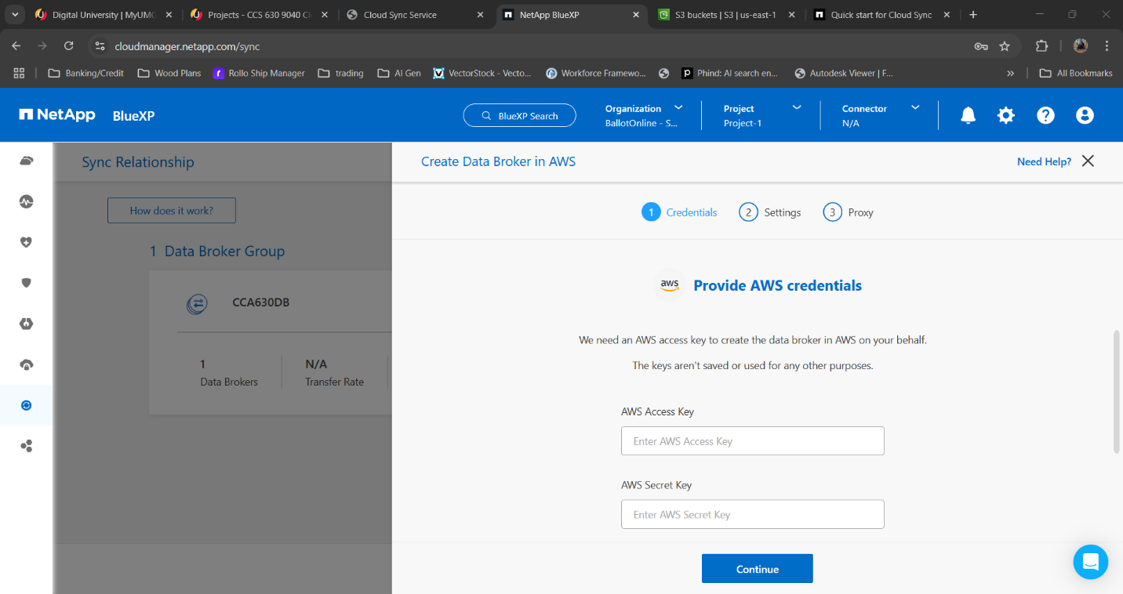
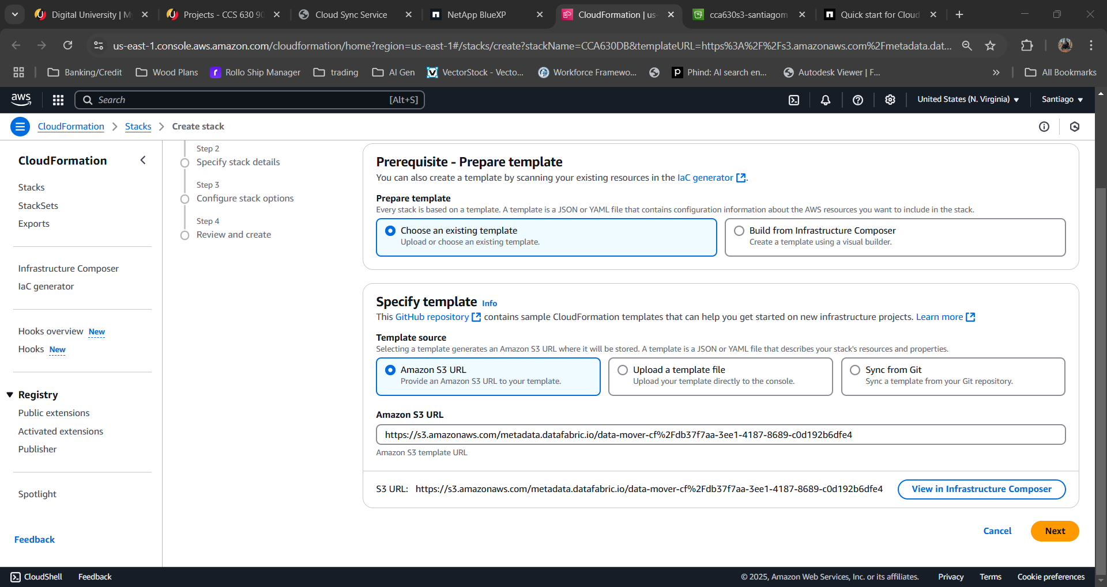
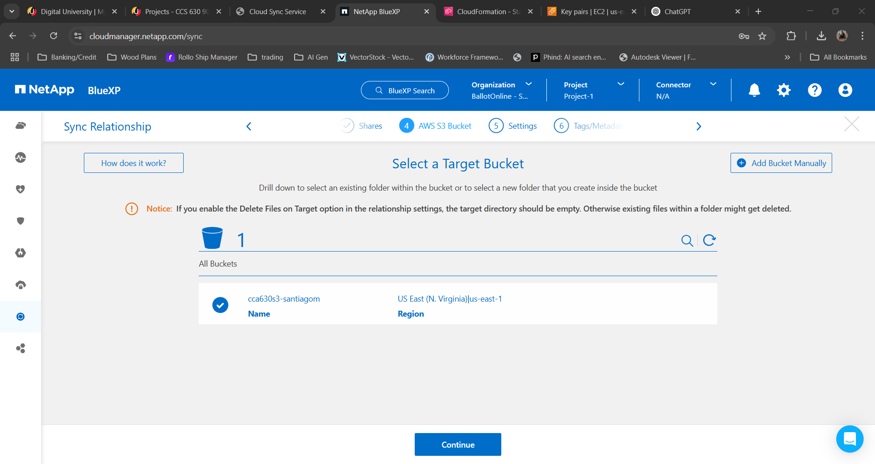
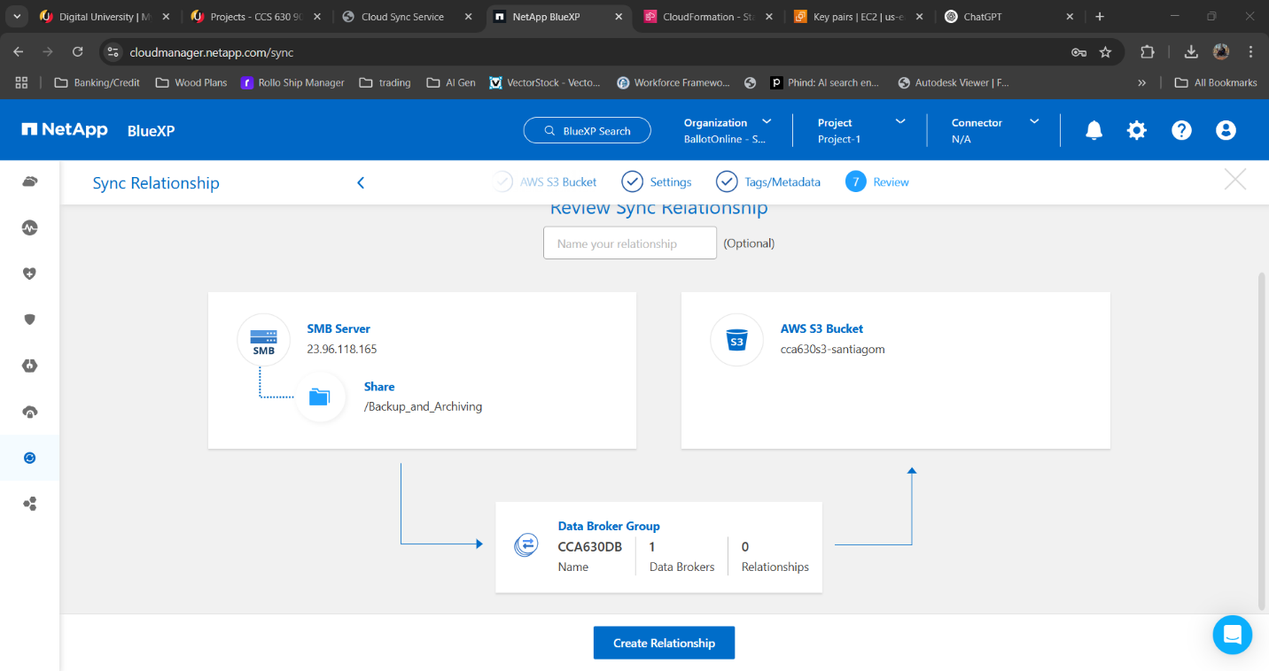

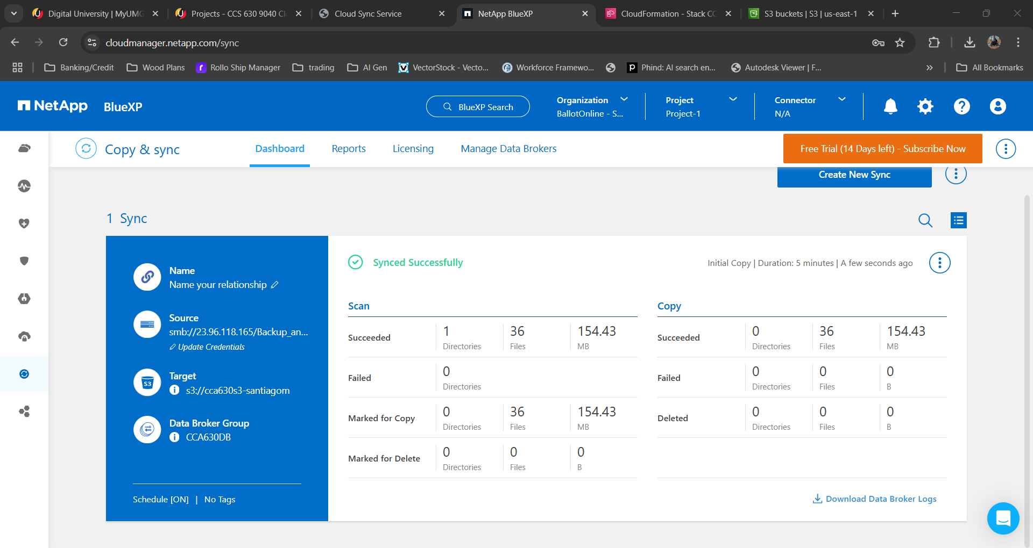

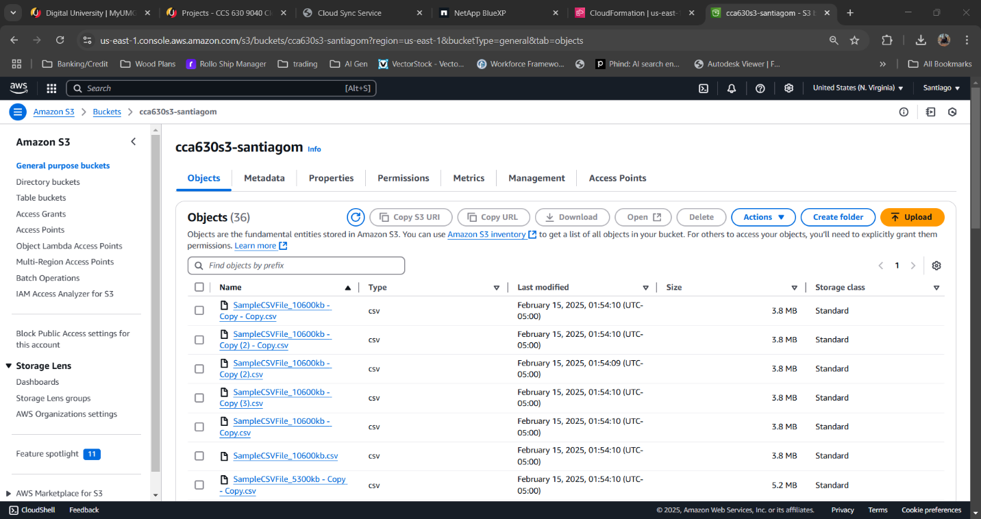
AWS CloudWatch
Finally we will set up billing monitoring. First go to the billing and cost management dashboard and in billing and payments section edit the alert preferences. Make sure the receive cloudwatch billing alerts is checked. Then go to the AWS CloudWatch console. Go to the alarms section and create a new alarm. When creating a new alarm you will see a estimated charges section, select that. Once created the billing alarm will appear as a widget on the dashboard.
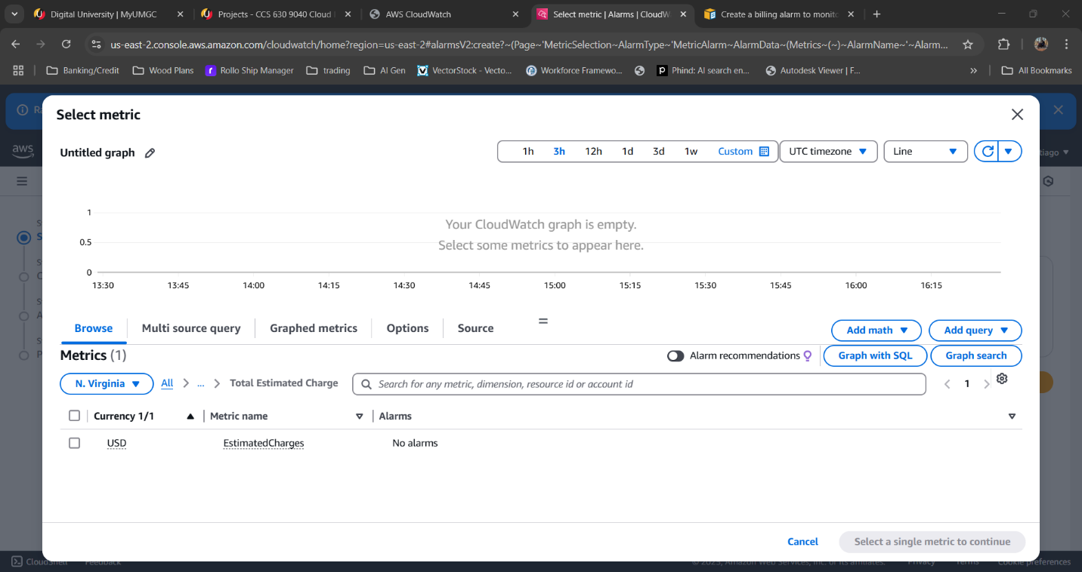
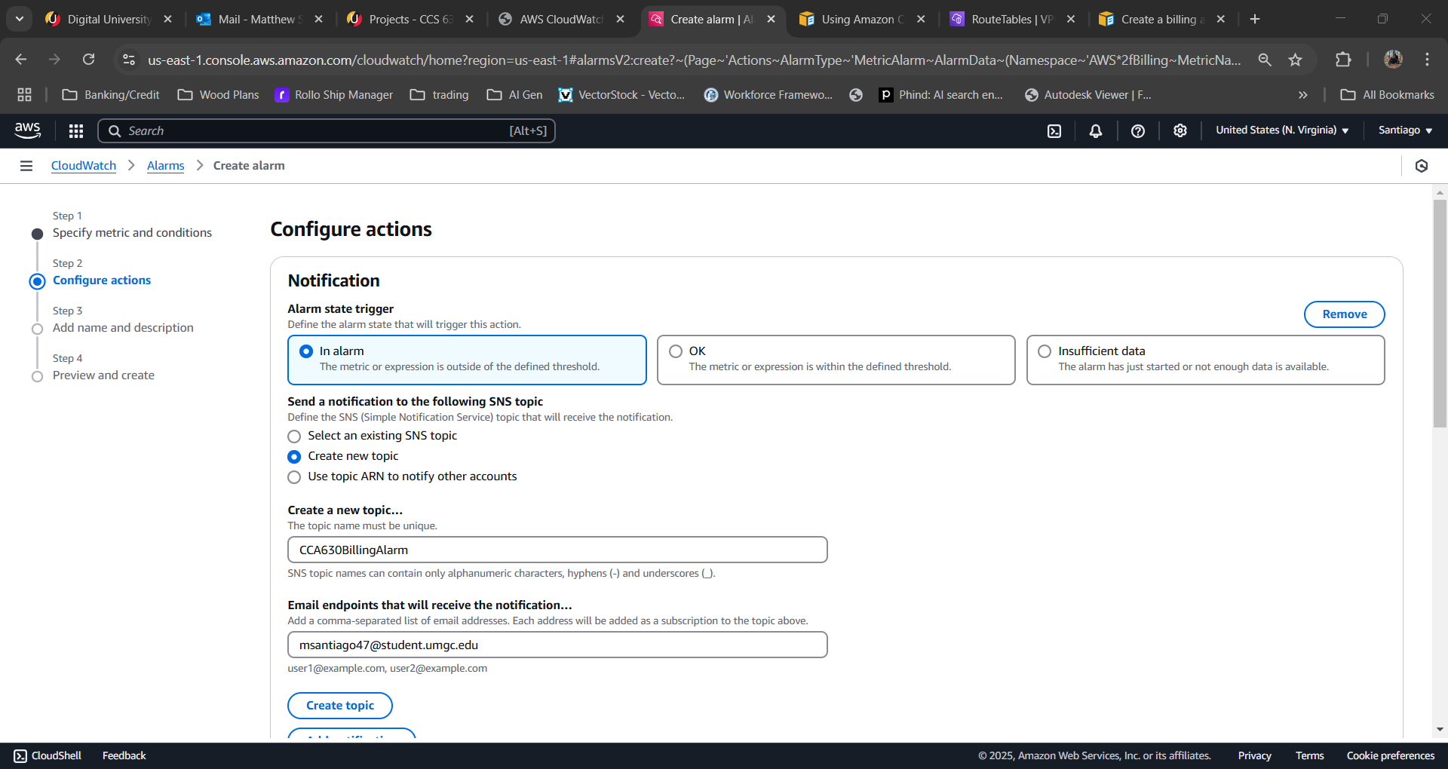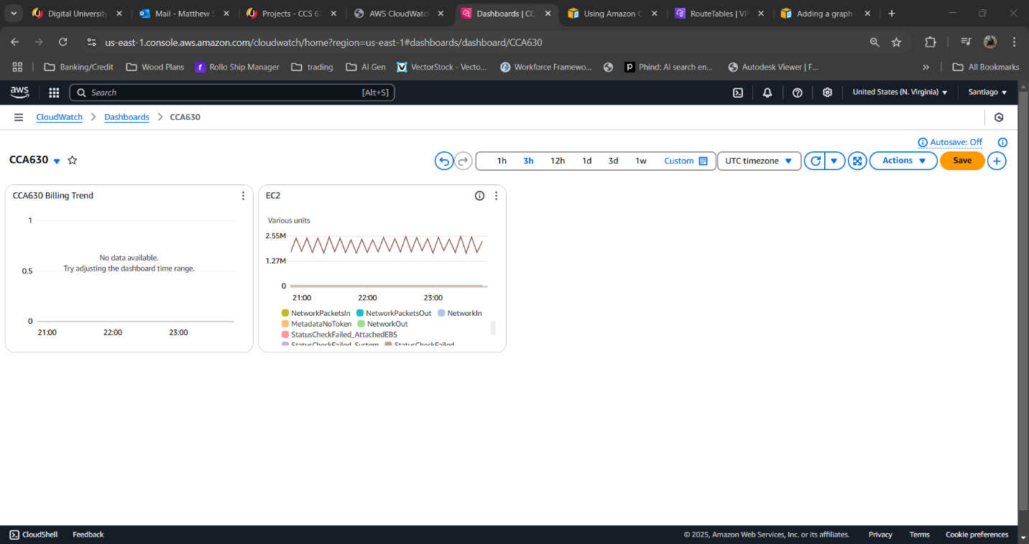
Limitations and Resources
A limitation of using Amazon S3 for cloud backups and archiving is the high cost of storing and accessing large amounts of data. As we increase the data, the monthly storage fees can be add up which means regular monitoring of costs is needed. Another limitations is the management of a multi layered deployment which will increase the complexity of the network. Lastly, vendor lock-in is also a concern. Amazon S3 is great at scalability and data reliability but this may complicate the migration to another provider in the future.
Amazon web services provides a wide range of resources. While AWS documentation offers clear and current information on setting up S3 buckets, managing costs and performance in CloudWatch. Using the NetApp BlueXP Cloud Sync service provides a simple way to transfer data between the data center and Amazon S3. Amazon Cloudwatch and billing tools make it easy to identify usage and prevent unnecessary spending. Using AWS tools and documentation, we will be able to optimize costs and have a robust, scalable cloud infrastructure for our future operational needs.

References
Amazon Web Services. (2024). Amazon S3. Retrieved from Amazon Web Services: https://docs.aws.amazon.com/AmazonS3/latest/userguide/s3-userguide.pdf

